GithuB eSSENTIALS

Repository:

Directory:

Branch:

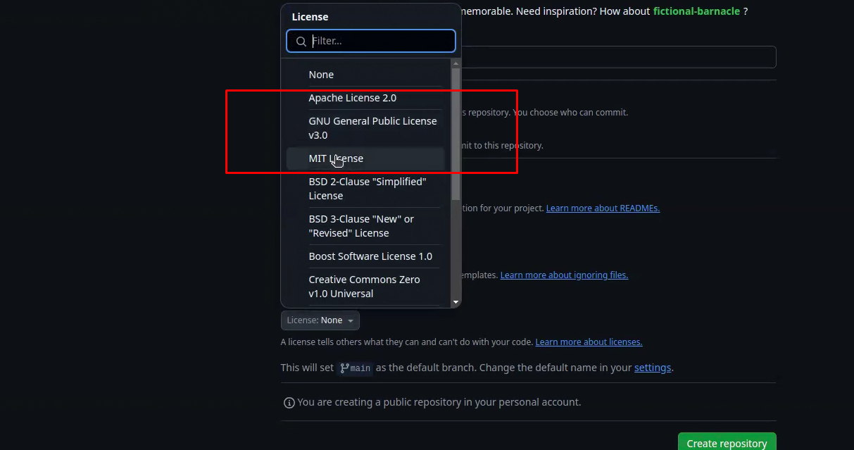

License

Master name change korar jonno. Git config –global init.defaultBranch <name>

Main -> Staging -> Production

Nano editor a kaj korar time:

nano file.extention